Sample: Si12 VASE with 6FDA-DAM pristine

Fit Results  MSE = 5.249  Thickness # 3 = 18.10 ± 0.017 nm  E Inf = 0.767 ± 0.006764  Angle Offset = 0.0345 ± 0.004173  % Thickness Non-uniformity = 2.75 ± 0.0276  n of B-Spline @ 632.8 nm = 1.57333 | Optical Model  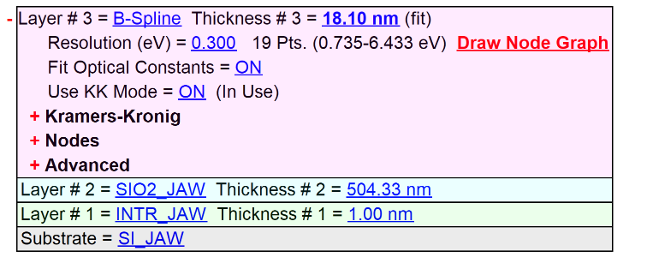

Experimental and Model Generated Data Fits

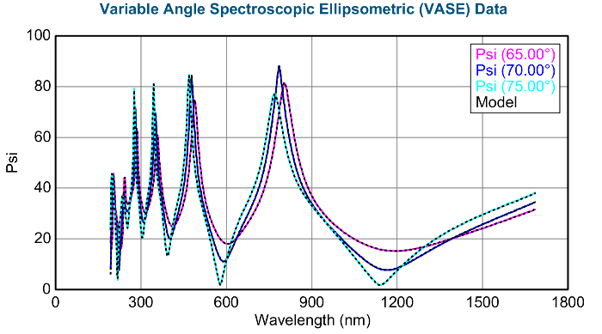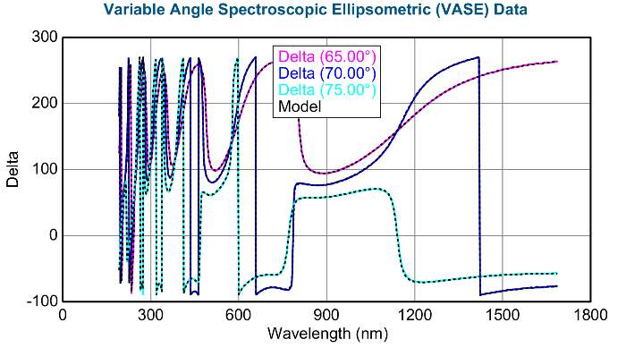
Sample: Si29 VASE with 6FDA-DAM pristine

Fit Results  MSE = 24.623  Thickness # 3 = 213.30 ± 0.248 nm  E Inf = 0.562 ± 0.0149  Angle Offset = -0.772 ± 0.0252  % Thickness Non-uniformity = 3.67 ± 0.0914  n of B-Spline @ 632.8 nm = 1.51720 | Optical Model  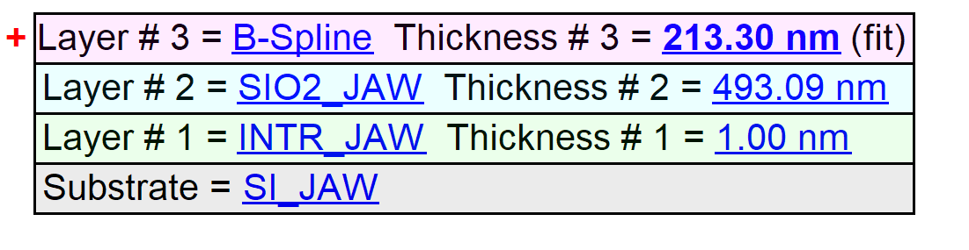

Experimental and Model Generated Data Fits

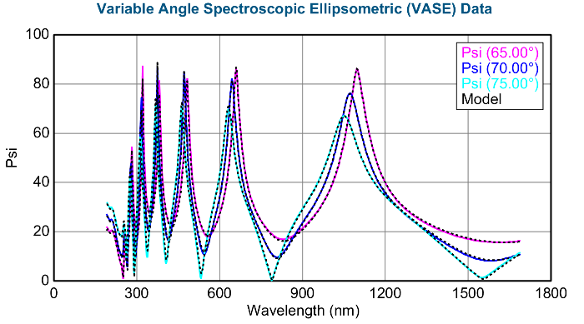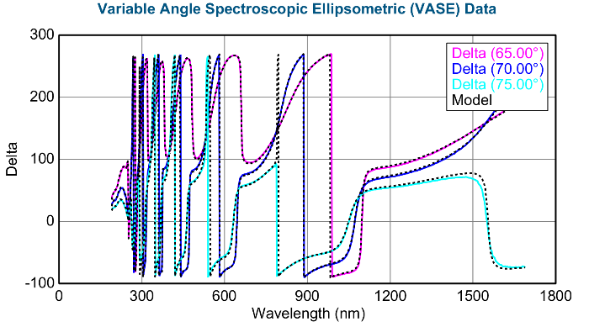
Sample: Si6 VASE with 6FDA-DAM pristine

Fit Results  MSE = 6.126  Thickness # 3 = 32.21 ± 0.022 nm  E Inf = 0.771 ± 0.006684  Angle Offset = -0.0476 ± 0.004920  % Thickness Non-uniformity = 2.80 ± 0.0288  n of B-Spline @ 632.8 nm = 1.56067 | Optical Model  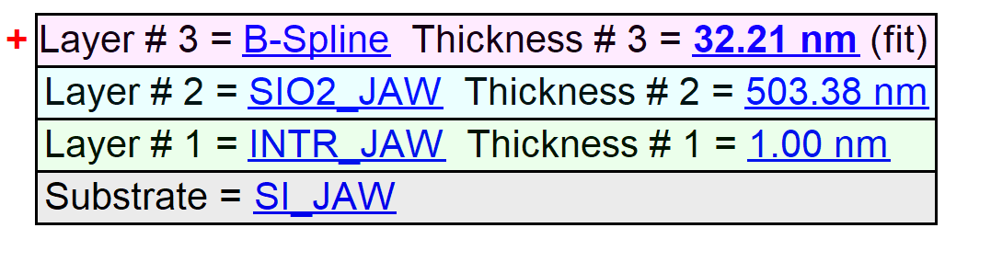

Experimental and Model Generated Data Fits

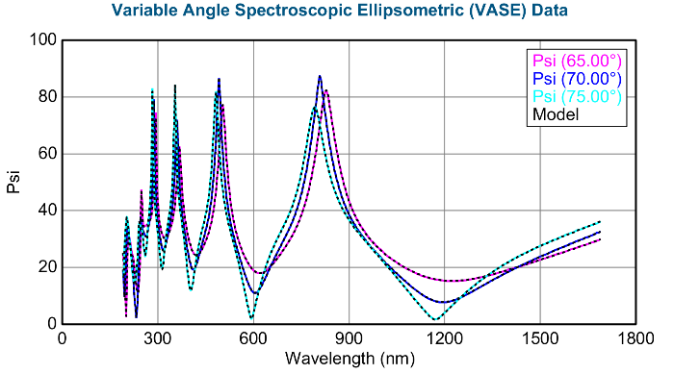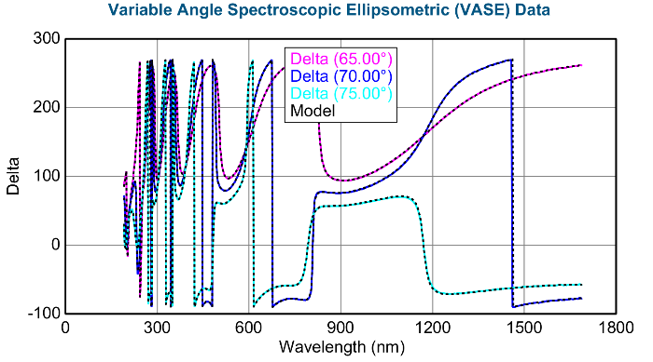
Sample: Si16 VASE with 6FDA-DAM pristine

Fit Results  MSE = 4.939  Thickness # 3 = 11.85 ± 0.015 nm  E Inf = 0.737 ± 0.008649  Angle Offset = 0.0299 ± 0.003967  % Thickness Non-uniformity = 2.71 ± 0.0261  n of B-Spline @ 632.8 nm = 1.57198 | Optical Model  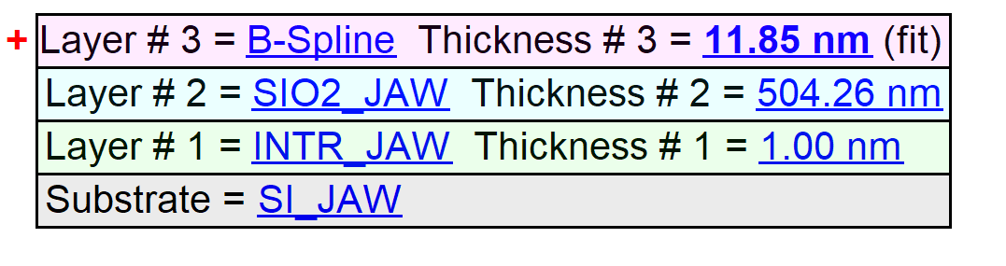

Experimental and Model Generated Data Fits

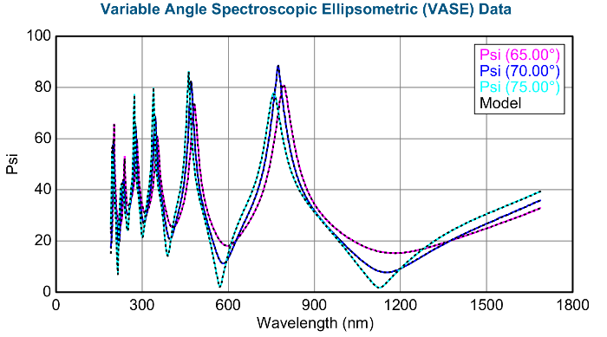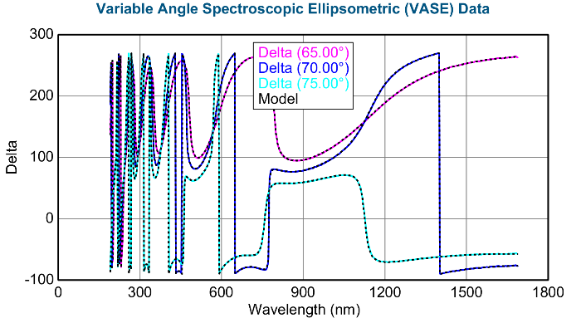

Sample: Si16 VASE with 6FDA-DAM 615C pyrolyzed

Fit Results  MSE = 4.605  Thickness # 3 = 7.73 ± 0.009 nm  E Inf = 0.846 ± 0.009662  Angle Offset = 0.0270 ± 0.002564  % Thickness Non-uniformity = 3.15 ± 0.0171  n of B-Spline @ 632.8 nm = 2.07525 | Optical Model  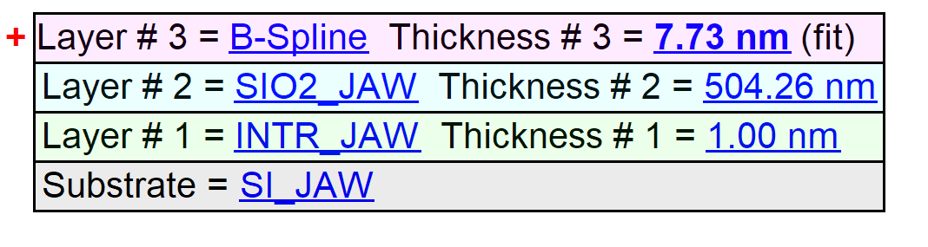

Experimental and Model Generated Data Fits

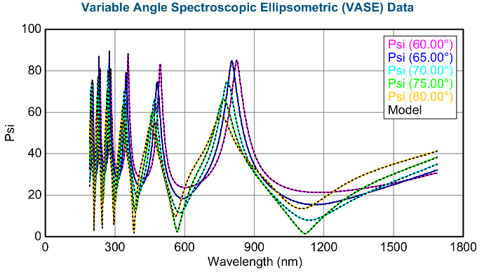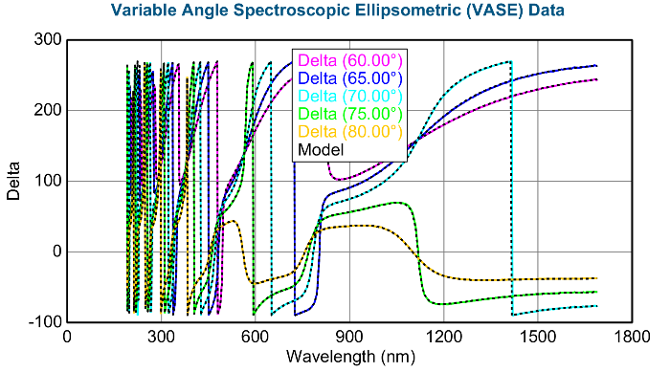
Sample: Si29 VASE with 6FDA-DAM 615C pyrolyzed

Fit Results  MSE = 12.364  Thickness # 3 = 153.78 ± 0.142 nm  E Inf = 0.745 ± 0.0151  Angle Offset = -0.311 ± 0.0159  % Thickness Non-uniformity = 2.77 ± 0.301  n of B-Spline @ 632.8 nm = 1.98606 | Optical Model  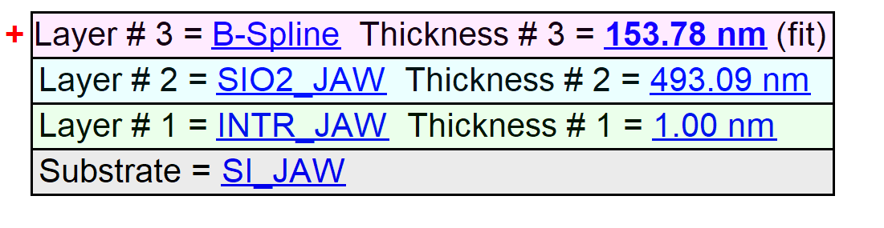

Experimental and Model Generated Data Fits

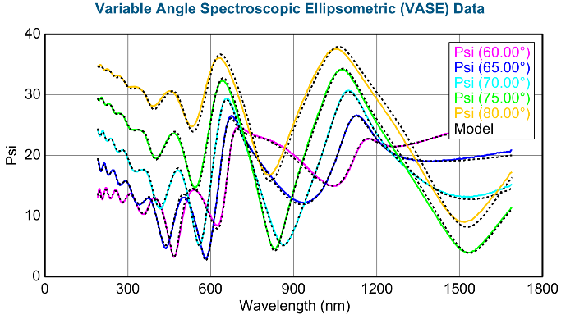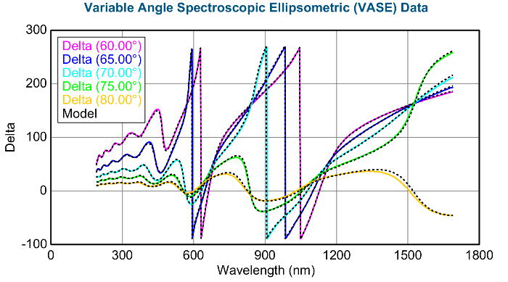
Sample: Si12 VASE with 6FDA-DAM 615C pyrolyzed

Fit Results  MSE = 4.421  Thickness # 3 = 12.55 ± 0.009 nm  E Inf = 0.835 ± 0.006069  Angle Offset = 0.0300 ± 0.002525  % Thickness Non-uniformity = 3.22 ± 0.0165  n of B-Spline @ 632.8 nm = 2.04747 | Optical Model  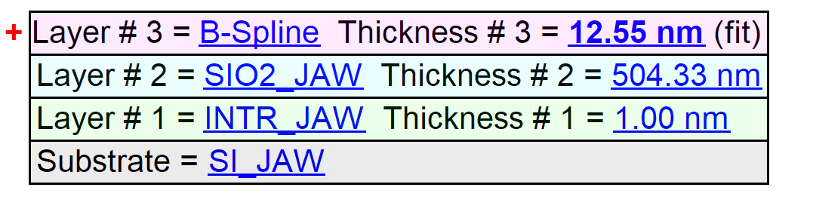

Experimental and Model Generated Data Fits

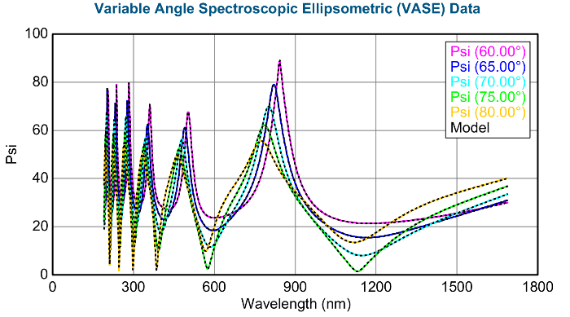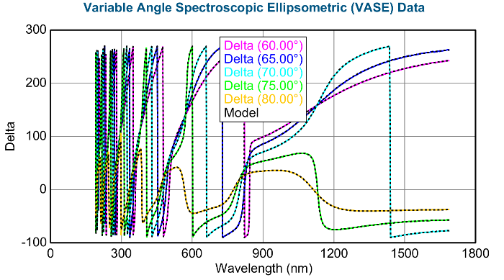
Sample: Si6 VASE with 6FDA-DAM 615C pyrolyzed

Fit Results  MSE = 5.001  Thickness # 3 = 22.49 ± 0.011 nm  E Inf = 0.917 ± 0.004765  Angle Offset = -0.00299 ± 0.003112  % Thickness Non-uniformity = 3.41 ± 0.0213  n of B-Spline @ 632.8 nm = 2.03904 | Optical Model  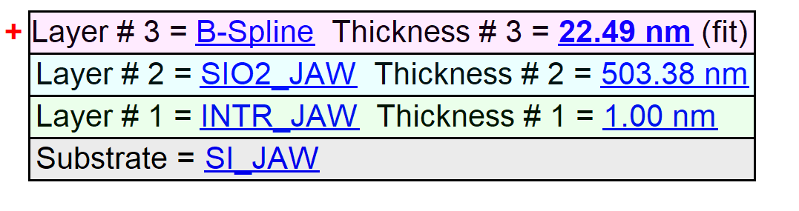

Experimental and Model Generated Data Fits

